Configuring The Mobile App For Controlling Motor Using Buttons

|  |  |
| --- | --- |
| **Team ID** | **PNT2022TMID50805** |
| **Project Name** | **Hazardous Area Monitoring for Industrial Plant powered by IoT** |

Application for controlling motor using buttons:

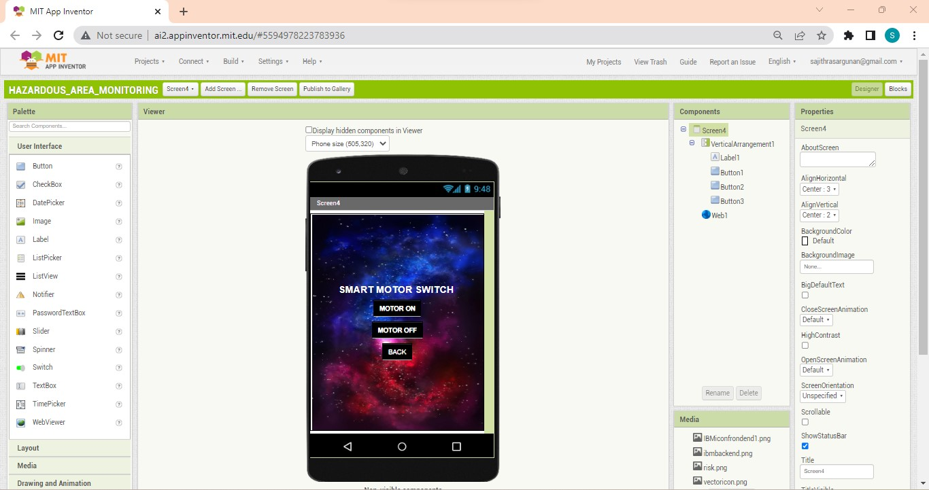

Blocks for controlling motor:

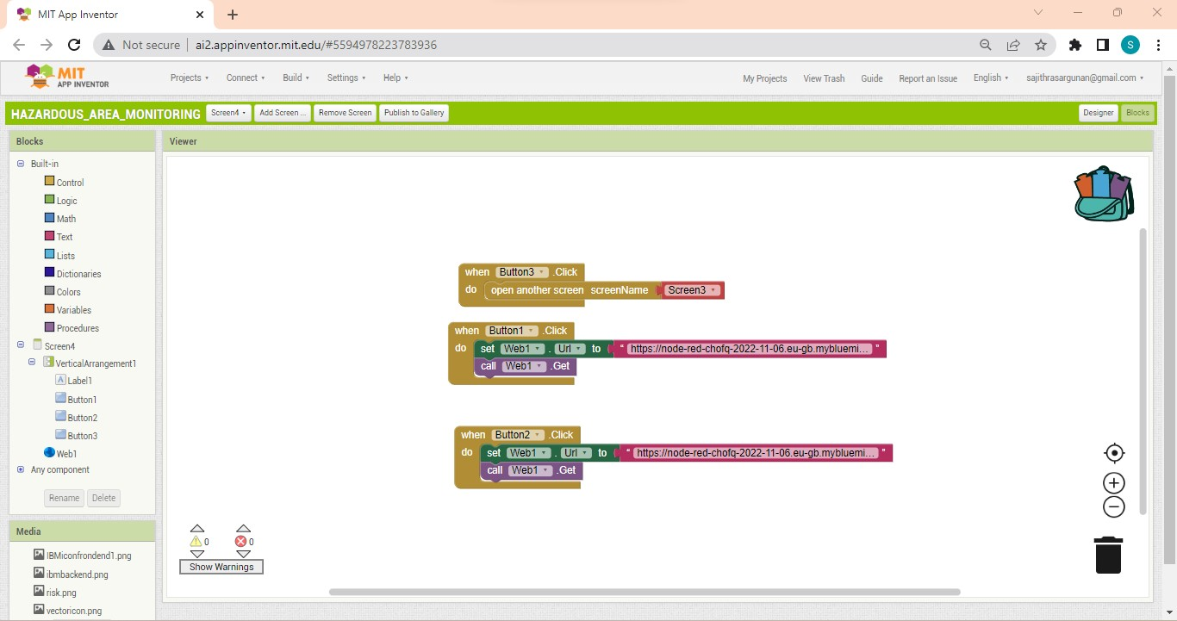

Motor is controlled by using buttons:

